Parallelization:(Sales Transaction)
Sales Transaction 5,00,000 millions we are distributing the task between four worker nodes and all results needs to be store in central database and there is one coordinator who is creating partition between four worker nodes.

Step 1:
sudo apt update
sudo apt install -y podman
podman --version
podman info

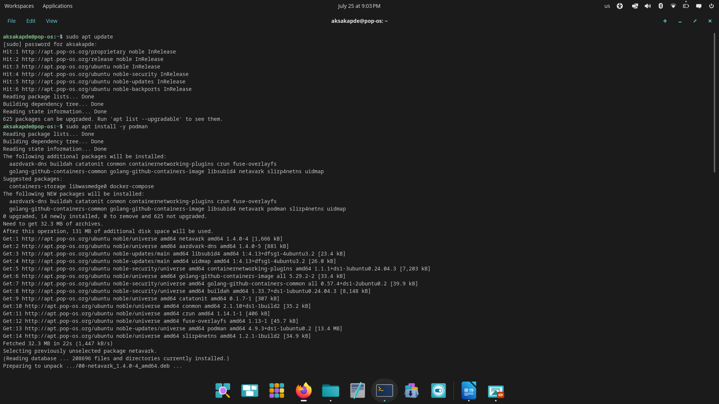

Step2:Create the project network

podman network create parallel-net

Step3:
Check the hostname IP
hostname -I
192.168.31.193 192.168.122.1 2409:40c0:3005:907e:66ac:9334:446f:6adc 2409:40c0:3005:907e:cb55:16a6:898d:52aa

Step4:
“Create the /etc/container directory using administrator permission.”
sudo command runs with adminstrator /root permission.
etc/containers/policy/json→ this is podman configuration image file(Which image needs to be pull) basically its download image policy file into that directory.

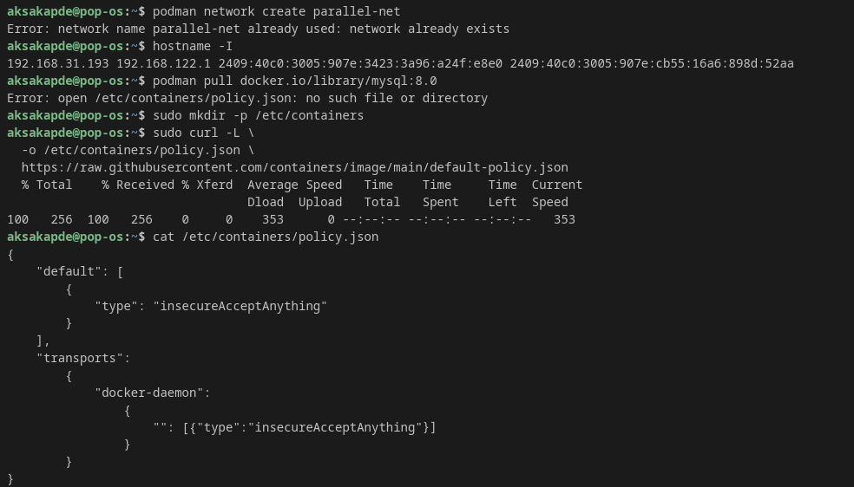

Step5: pull the sql image from podman docket I.o
and then start podman run sql
you can see in podman ps inside container id (My SQL is Running)

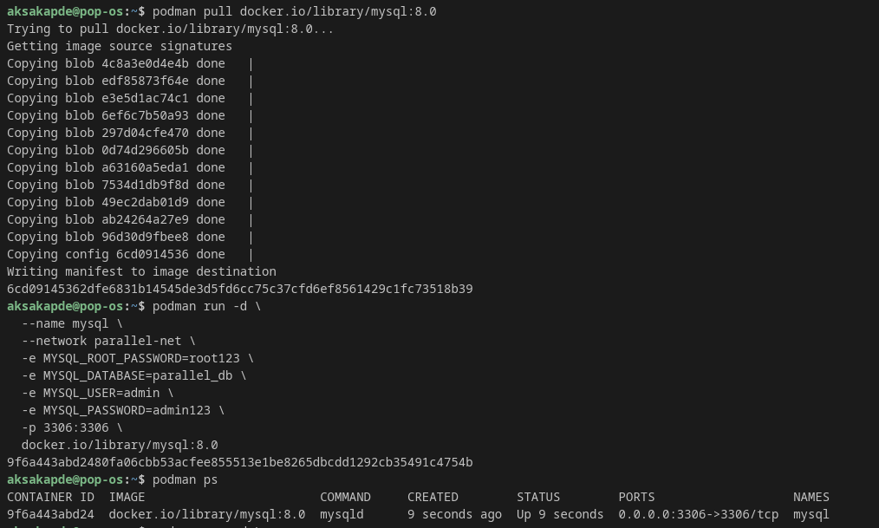
Step 6: Create mkdir -p ~/parallel-project
cd ~/parallel-project

Pull the jupyter image in it

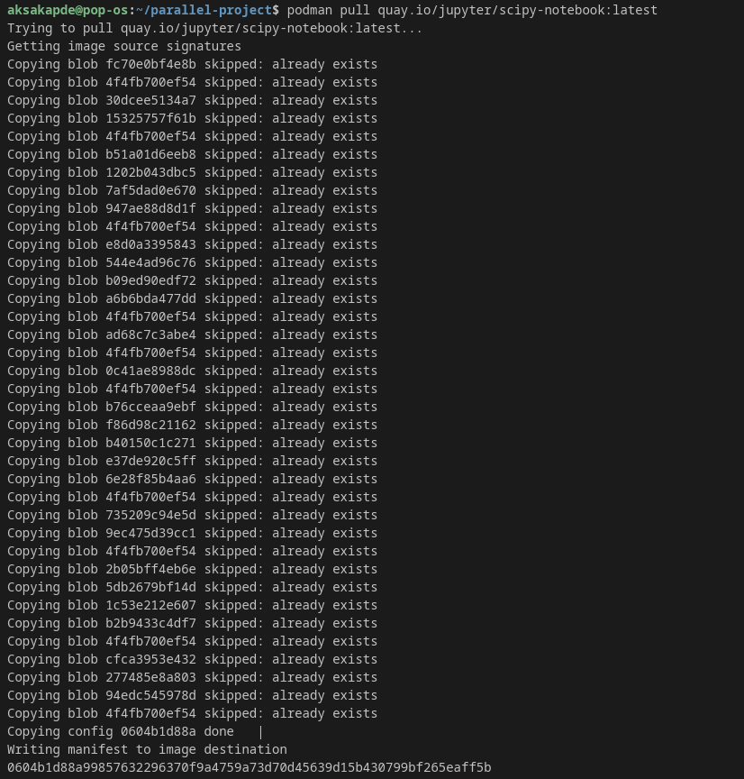

Step 7: Start the jupter notebook(Coordinator)

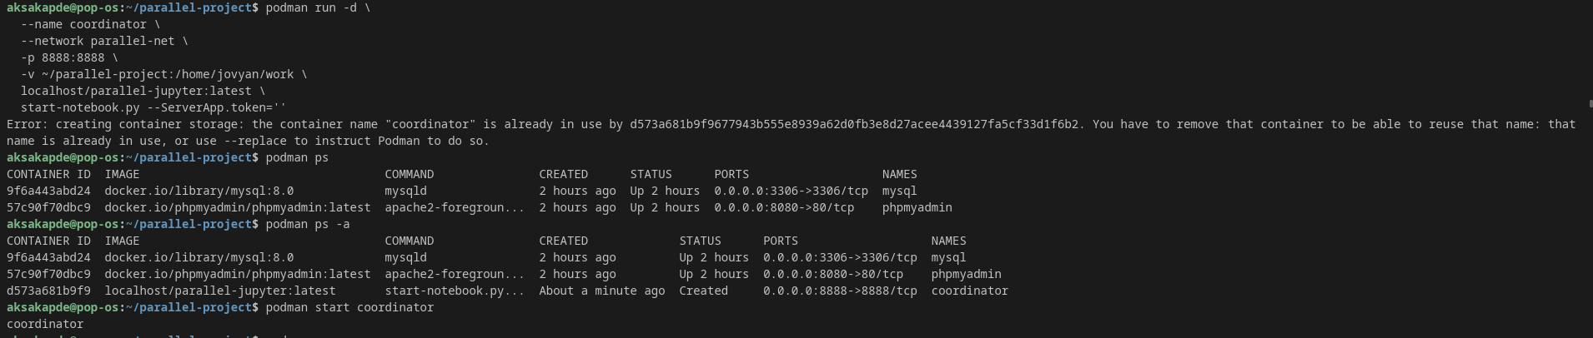

Step 8:Check the logs of Coordinator

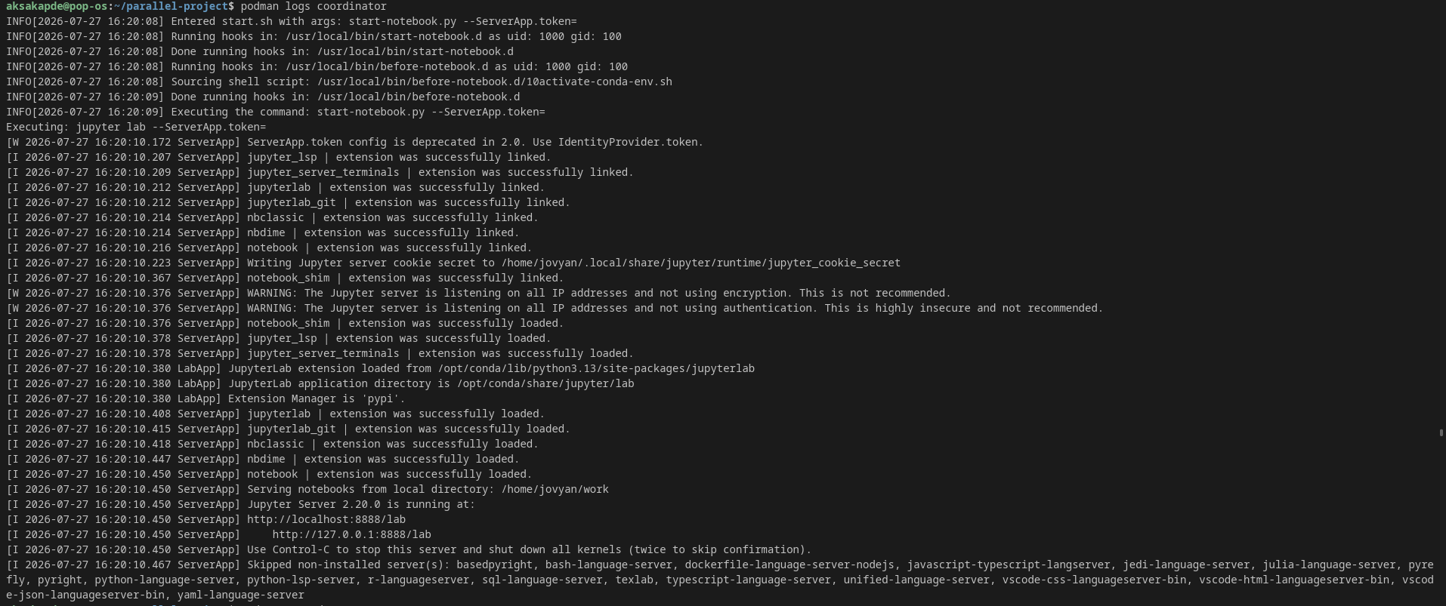
Step 9: Start all the 4 worker nodes(Jupter notebook)

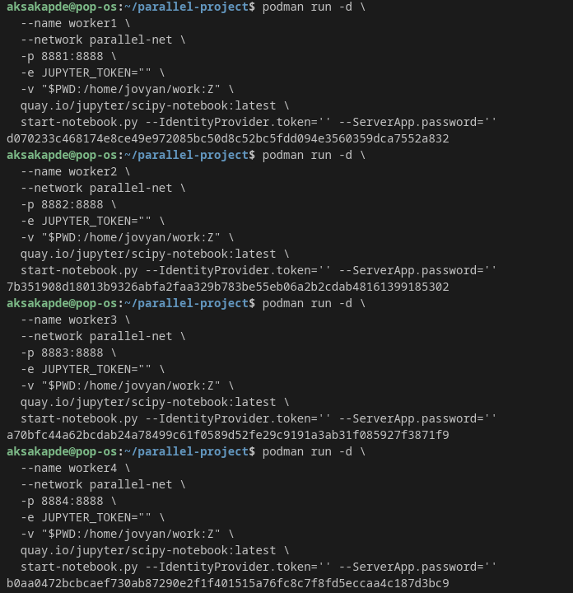

Step 10: check the status of conatiners using podman-ps and after that start coordinator

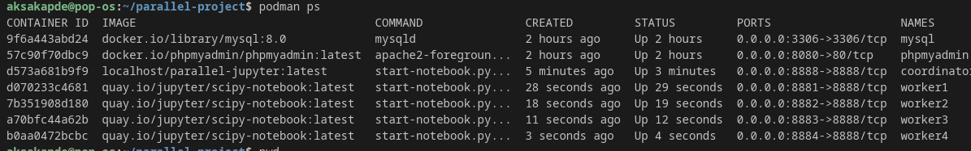

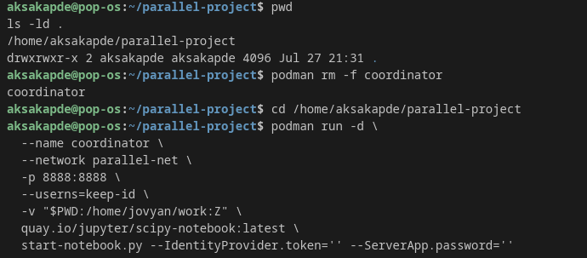

step 11: Create a directory mkdir/parallel_project/data
afterwards go to sales and inside that sales_500000.csv total records found 597 M.(we can perform read, write operations as well ).

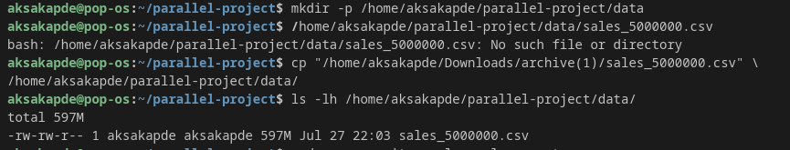

Step 12:as you can see everything we are having in parallel-project folder also 4 worker nodes and coordinator, My SQL(central database). So now we can perform partition and parallelization below step by step.

Step 13: Coordinator is the one which will create four partition among worker nodes lets start with basic calculate total revenue of sales by per item so coordinator will distribute the tasks into 4 partition(125000) 4 worker nodes will do parallely results will be stored in database
lets first setup coordinator so connection can be established between 4 worker nodes.

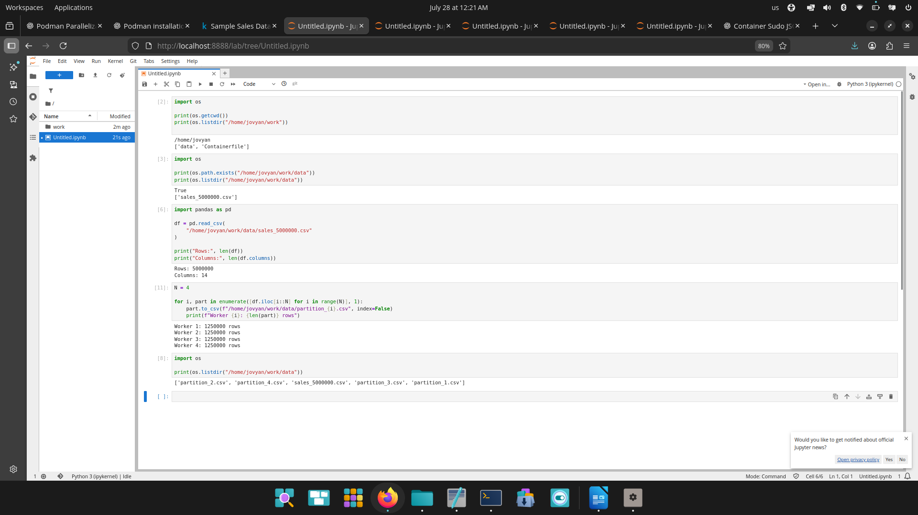

One directory parallel data we created inside that we create location of container(coordinator, worker nodes and database) can access also dataset we keep there.

Step 14: Now partition is created let show how parallelization works we are having sales data consists of 5,00,000.csv (millions) we want to analyze giving workload on single worker node can create problem hence we will distribute the task.

Worker 1 — Product Analytics

Tasks:
A. Total sales by product category
B. Total profit by product category
C. Units sold by product category
D. Average selling price
E. Average profit per transaction

Which product categories are high-volume, high-revenue and high-profit?

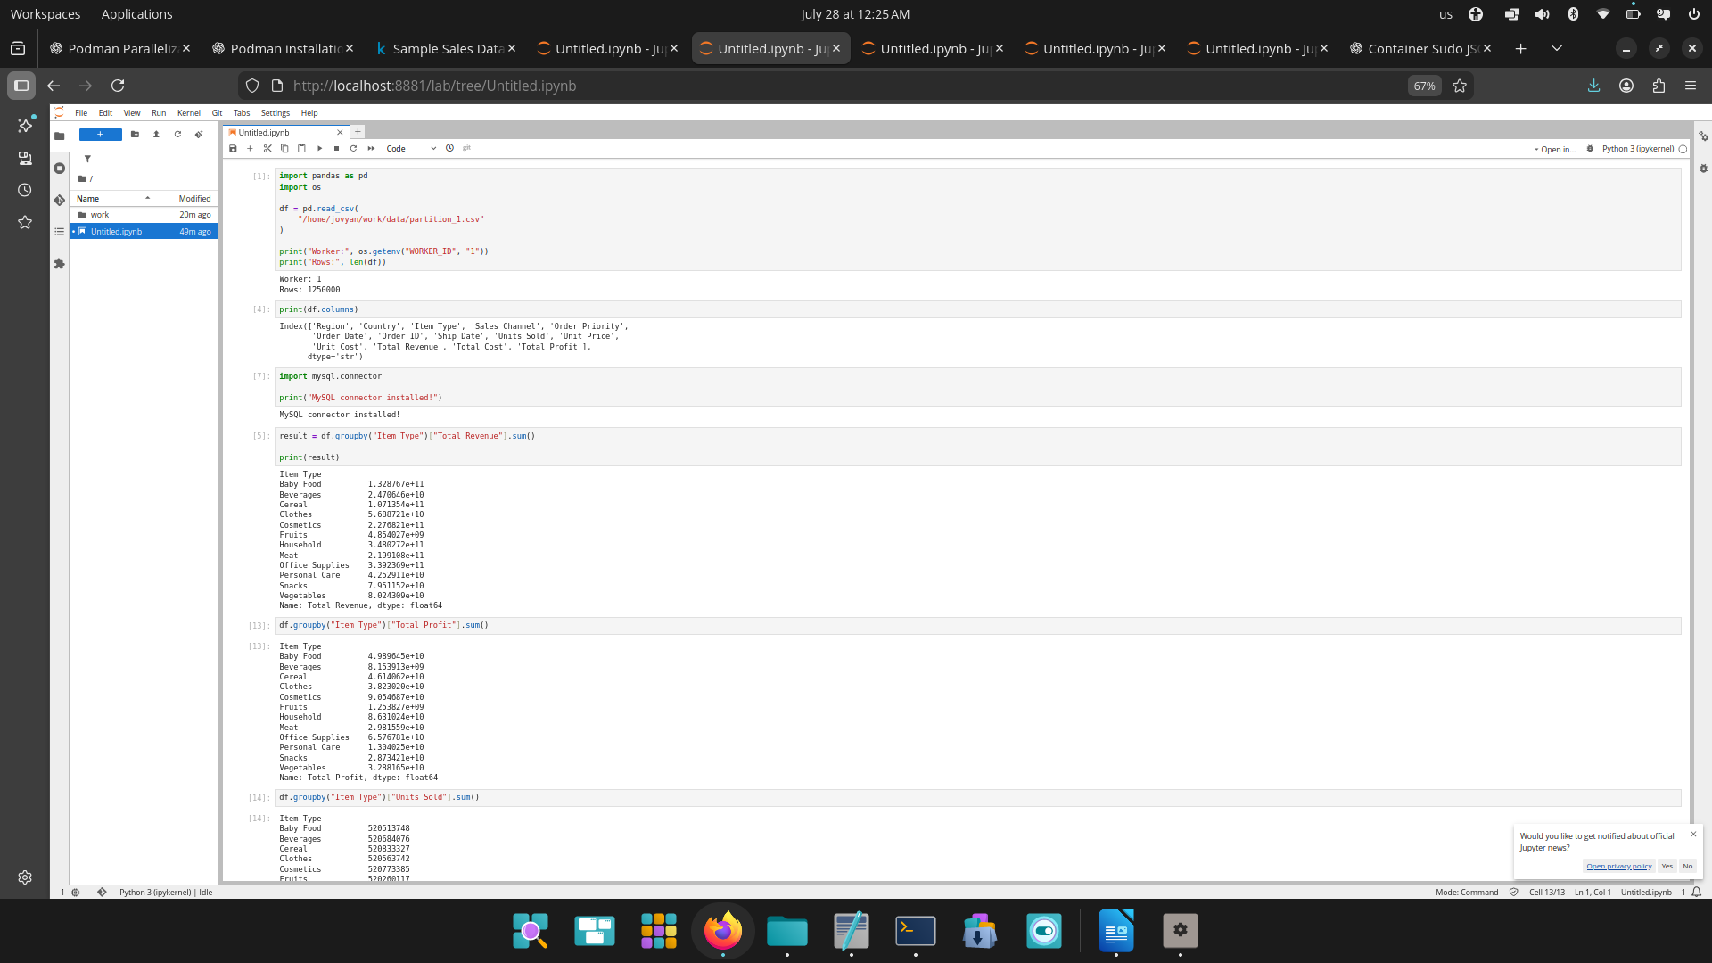

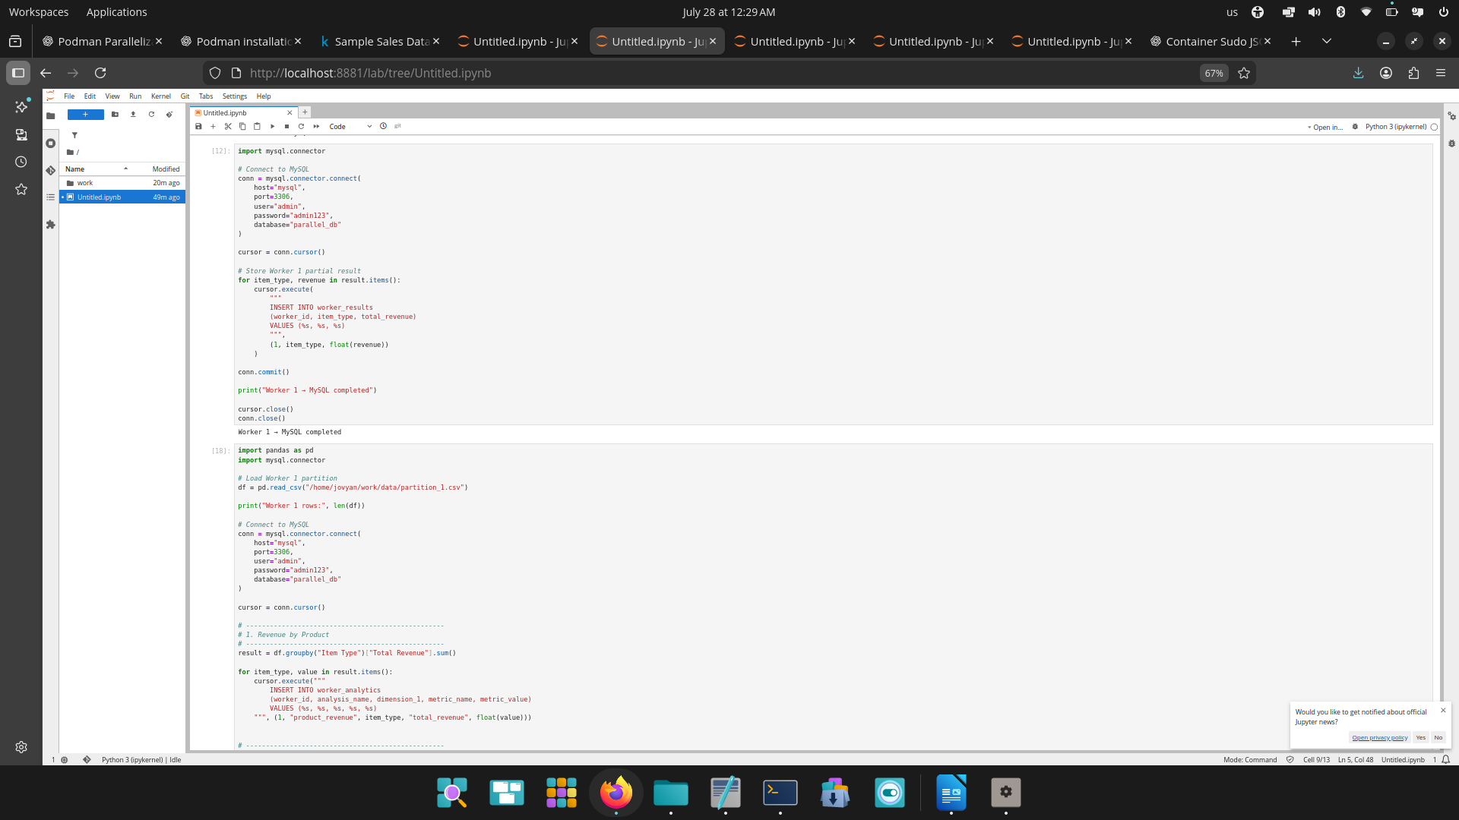

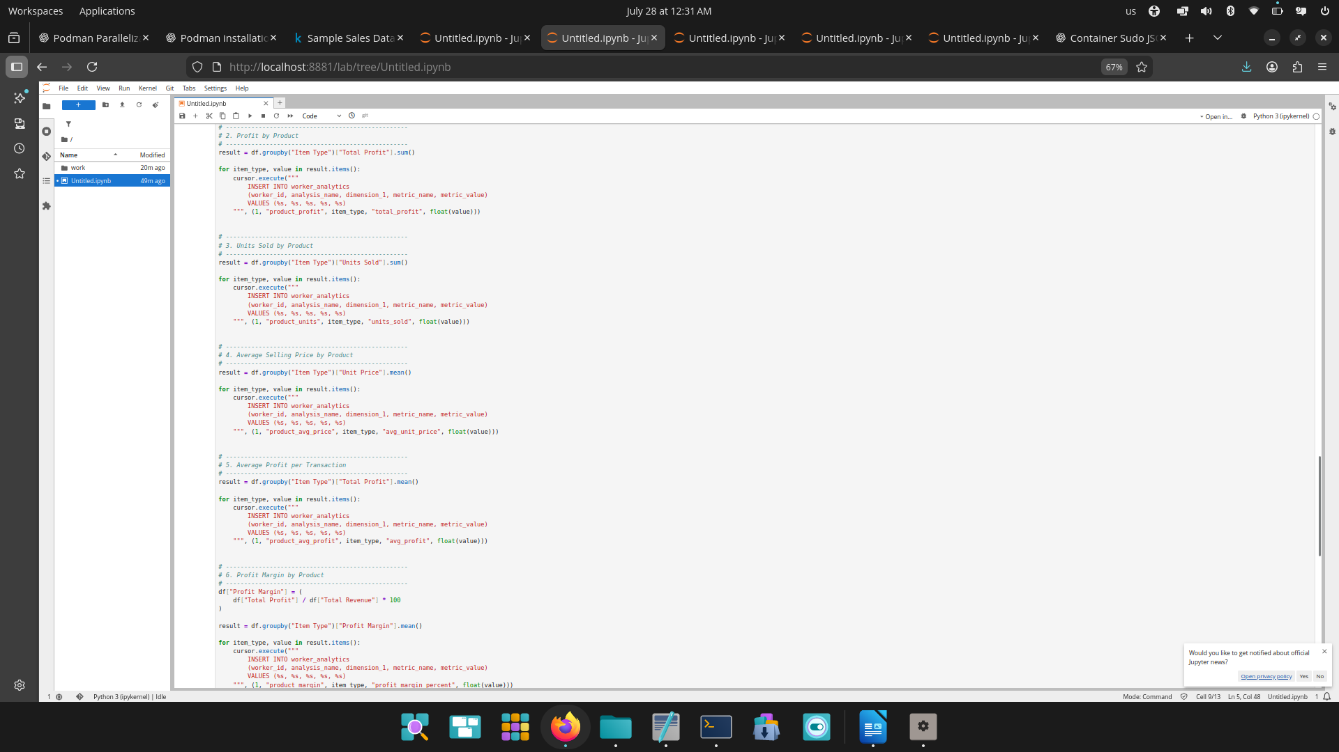

Worker 2 — Geographic Analytics
A. Revenue by region
B. Profit by region
C. Units sold by region
D. Revenue by country
E. Profit by country
F. Average revenue per transaction by region

Which regions and countries are the strongest markets?

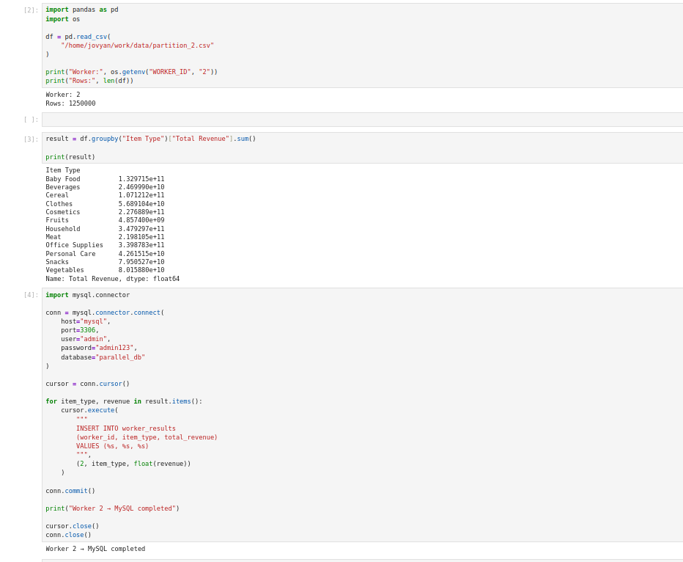

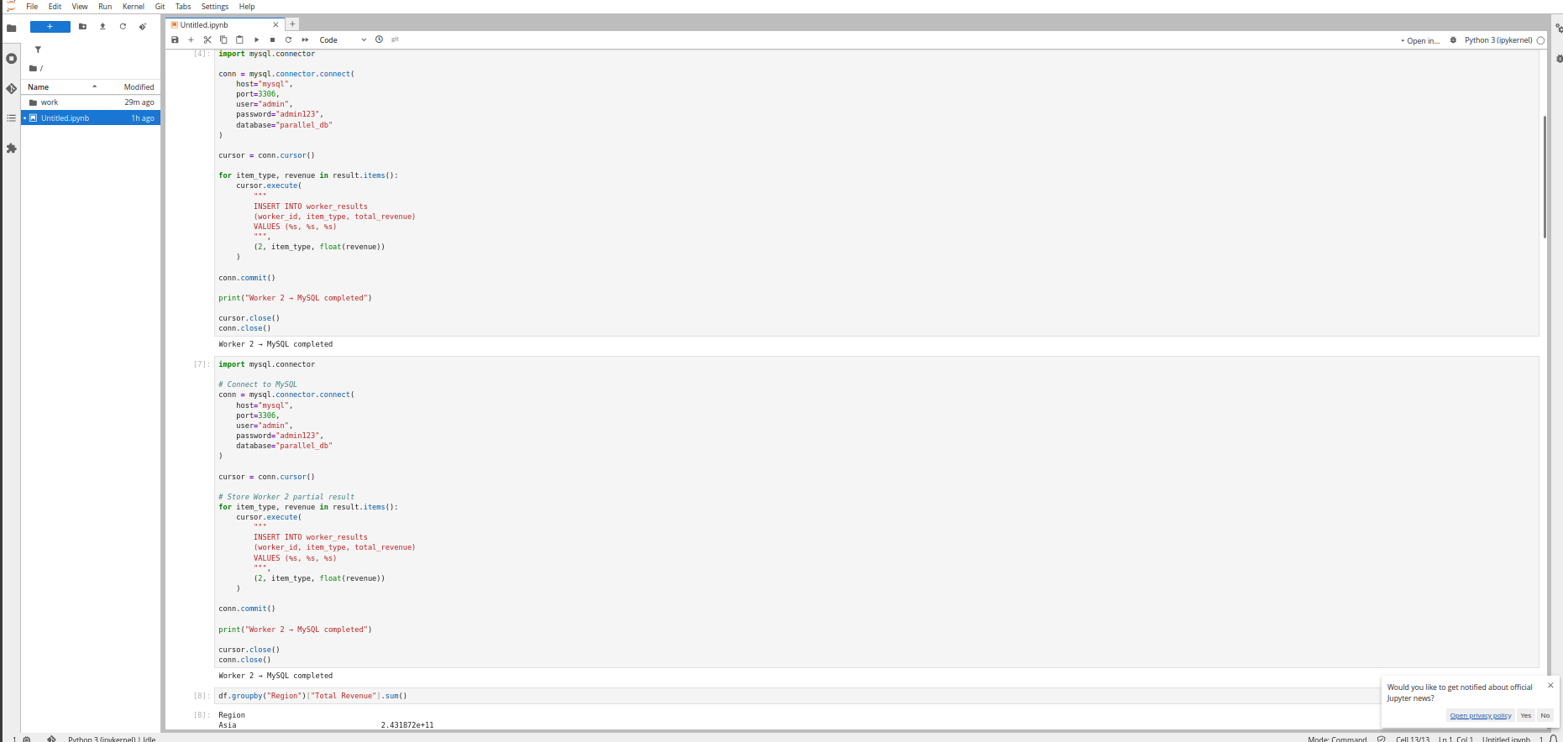

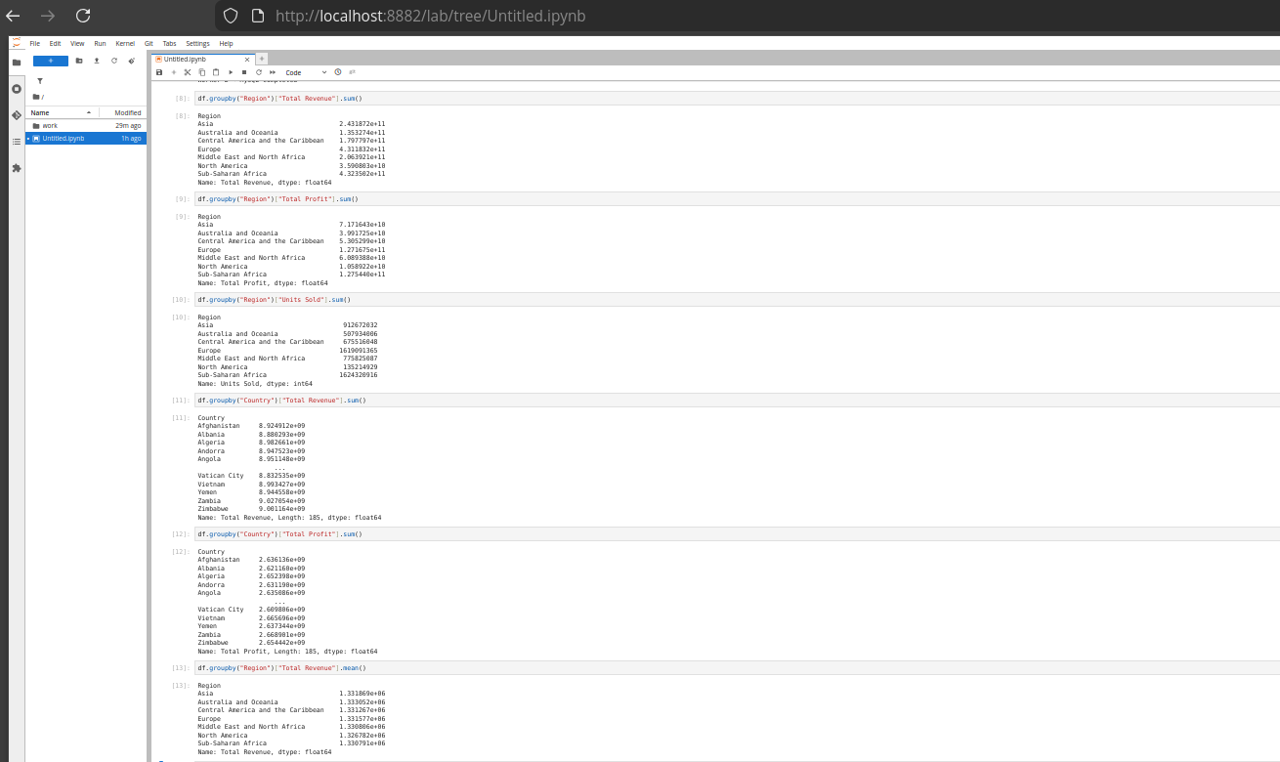

Worker 3 — Sales Channel Analytics
A. Revenue by sales channel
B. Profit by sales channel
C. Units sold by channel
D. Average revenue per transaction
E. Channel × product
F. Channel × region
Which sales channels and channel-product combinations generate the most business?

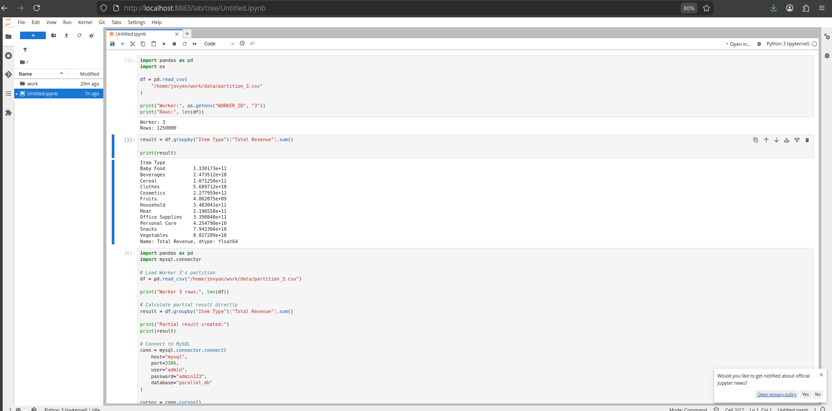

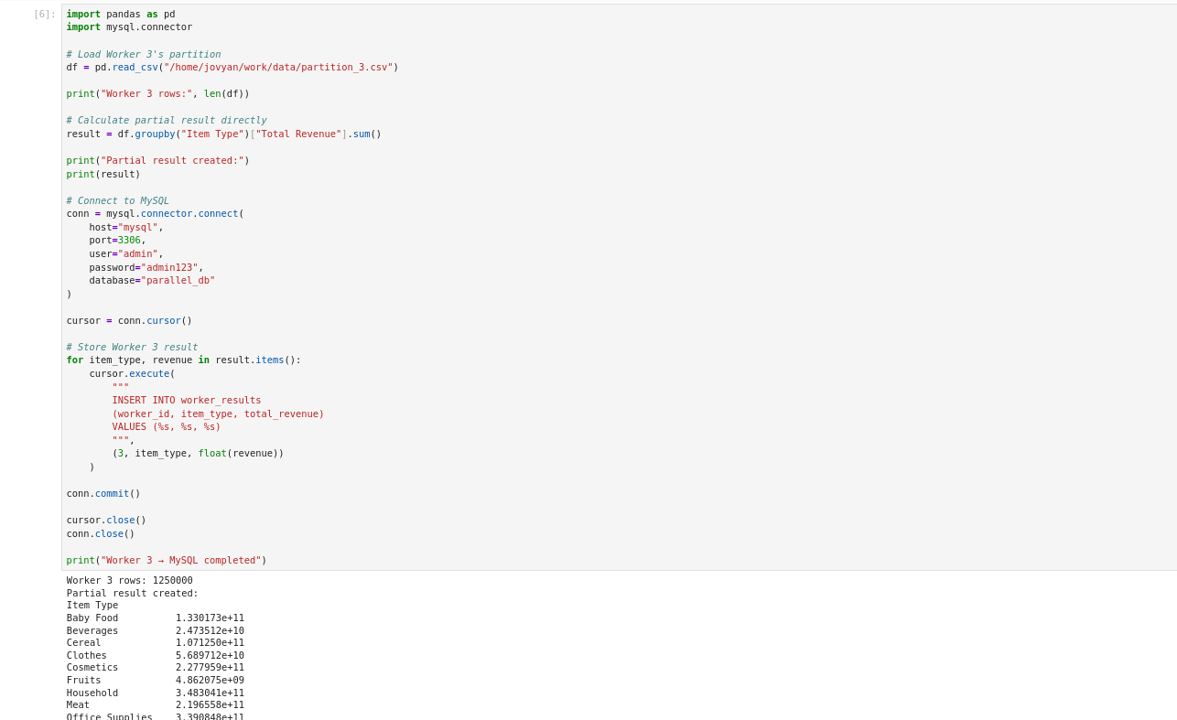

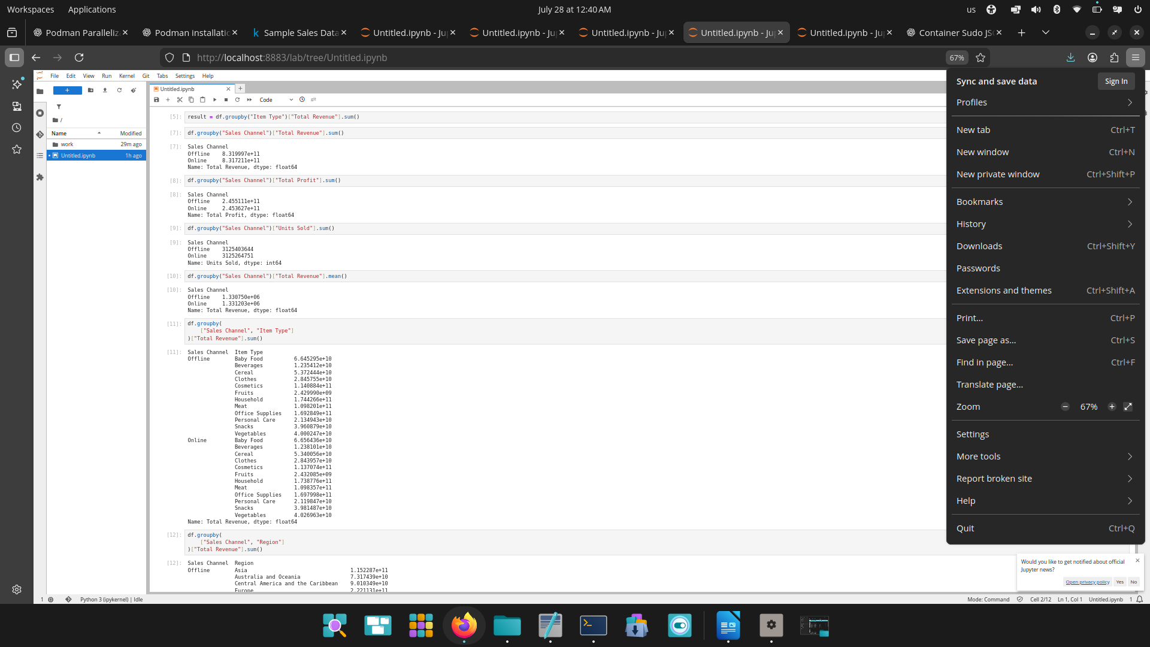

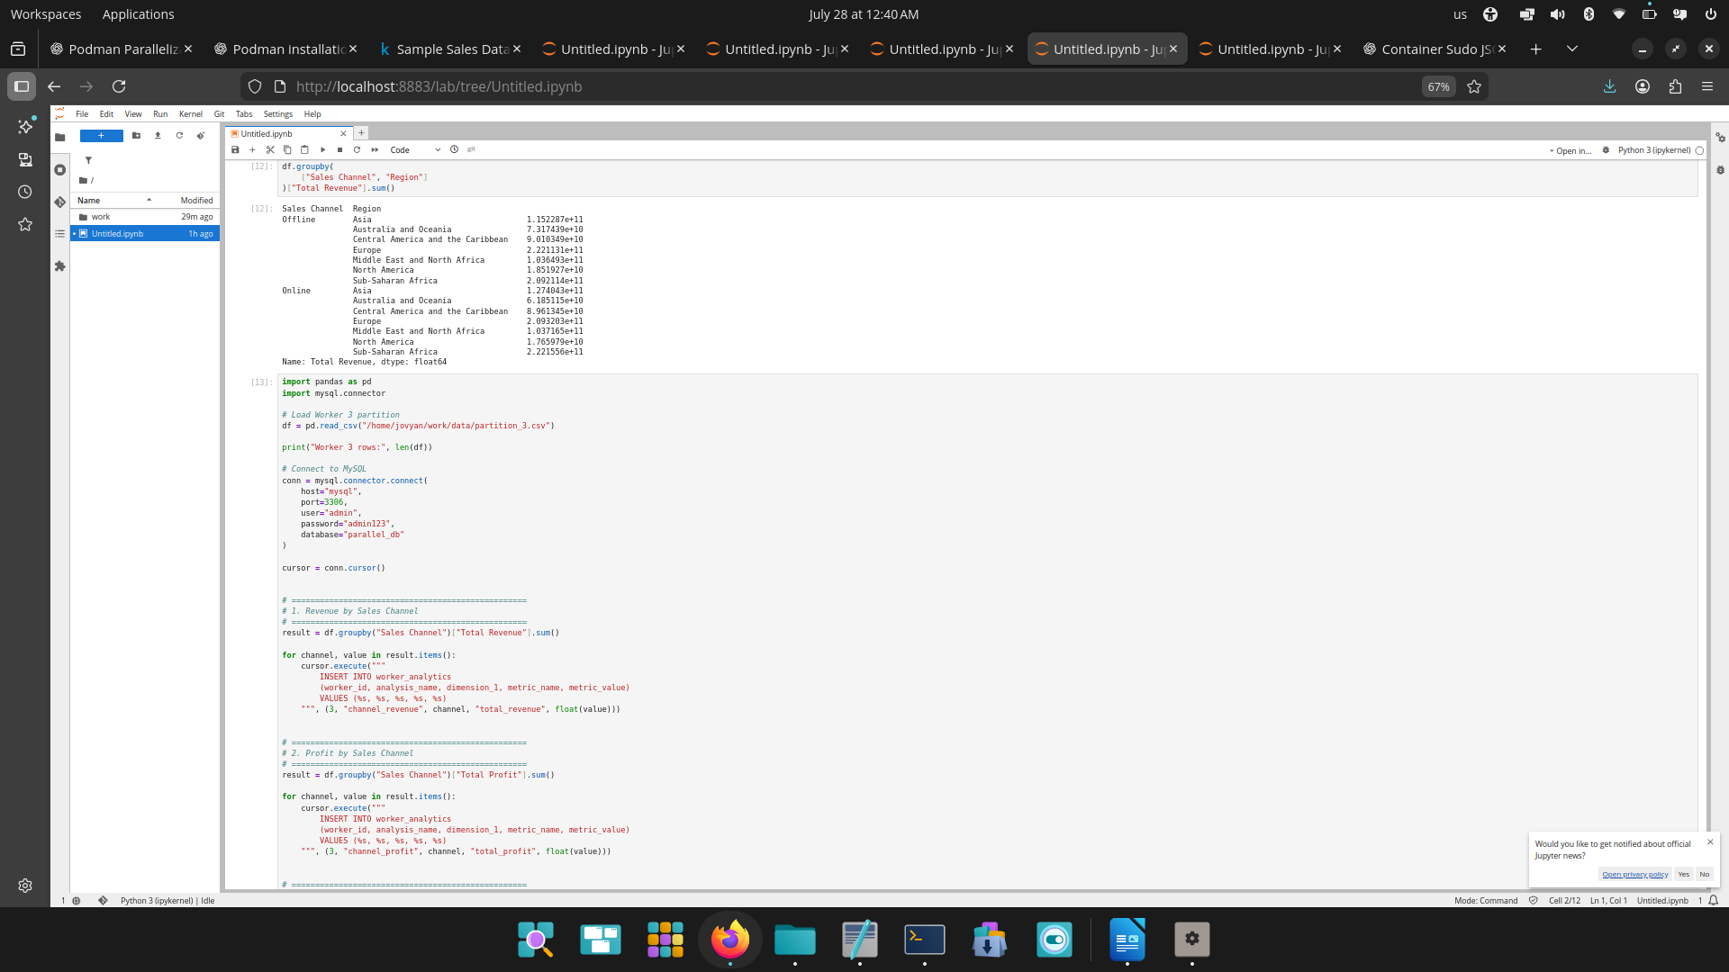

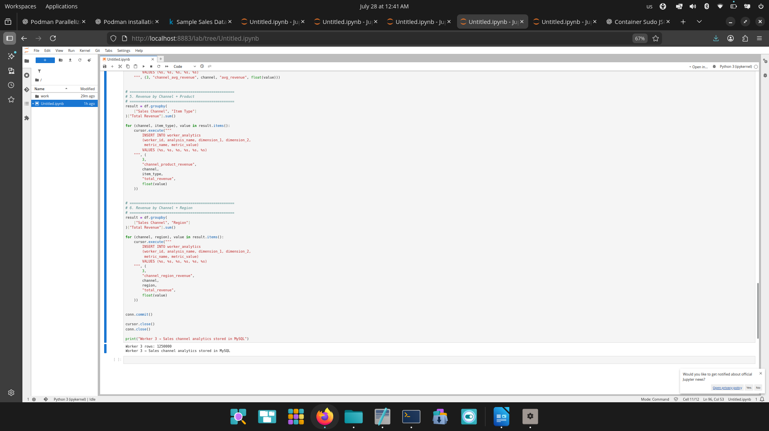

Worker 4 — Time & Profitability Analytics
A. Monthly revenue
B. Monthly profit
C. Monthly units sold
D. Revenue by order priority
E. Profit by order priority
How does performance change over time, by priority, revenue, cost and profit?

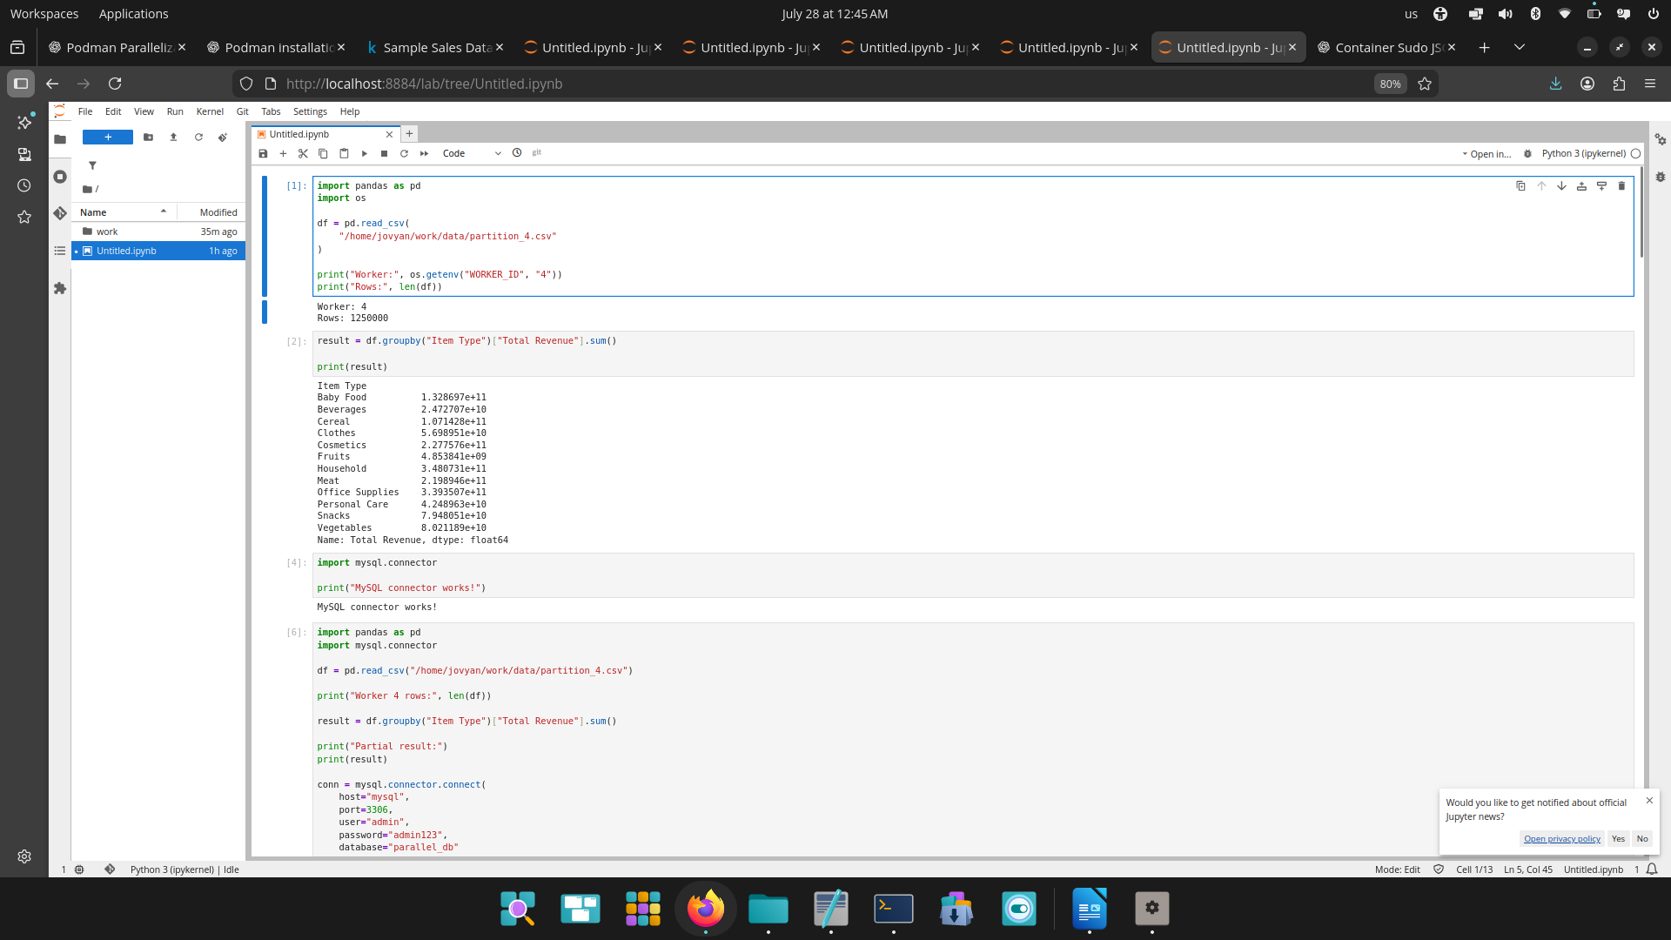

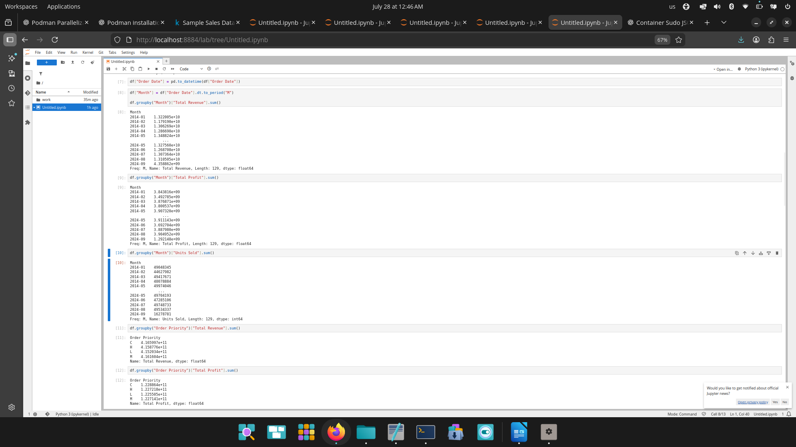

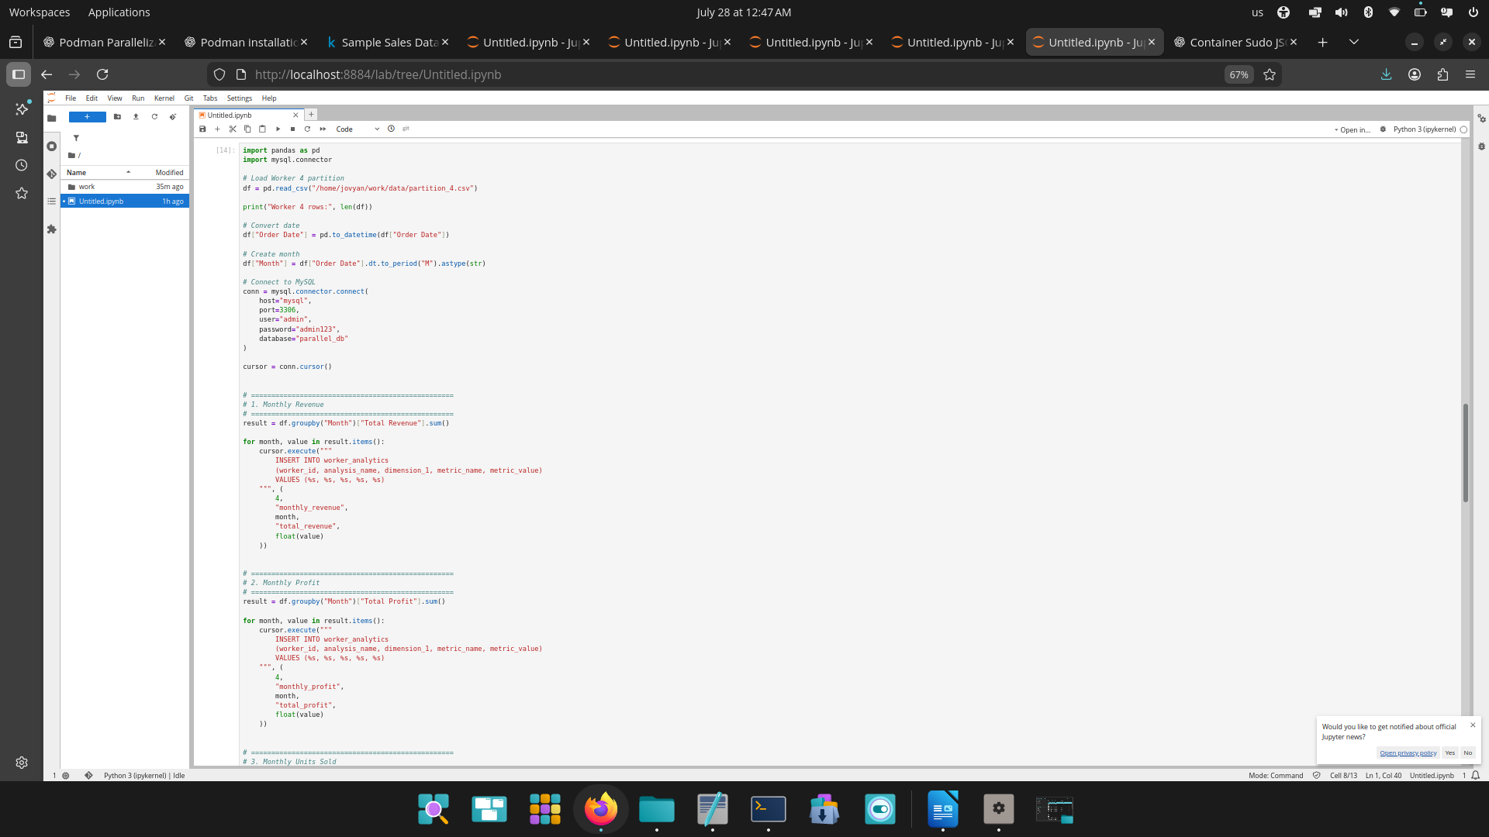

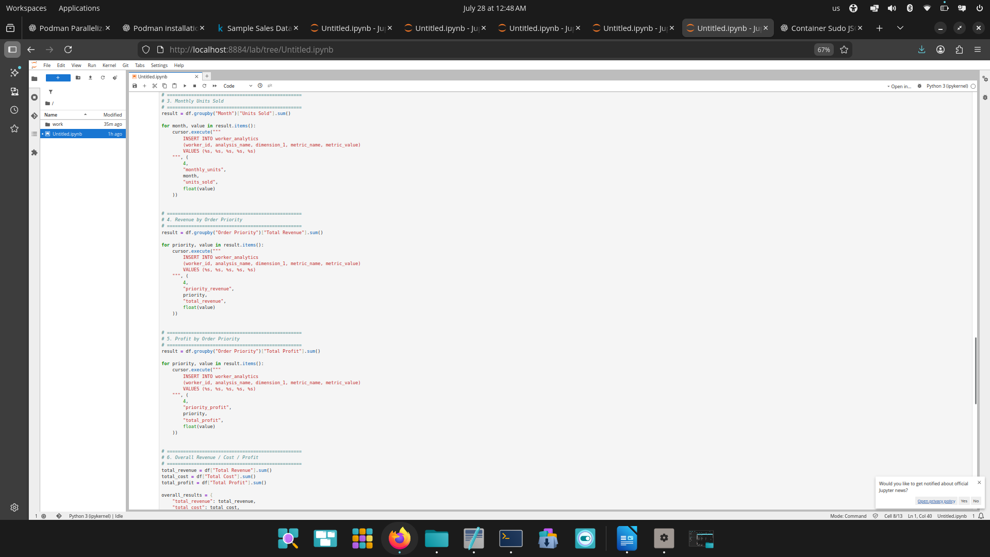

Now lets check database all analysis done by worker nodes results are stored in one database(My SQL)

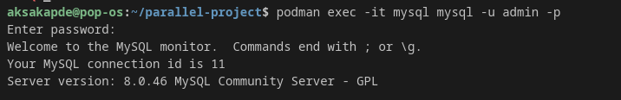

step 12: you can check worker 1 node total revenue is stored in database.

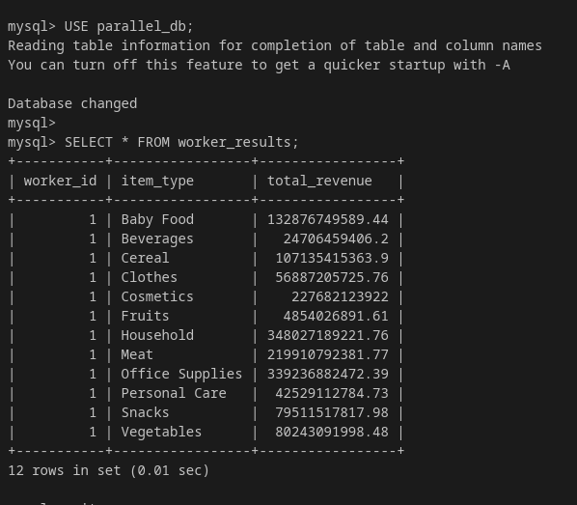

you can see results of woker 1 which we calculate is stored in database

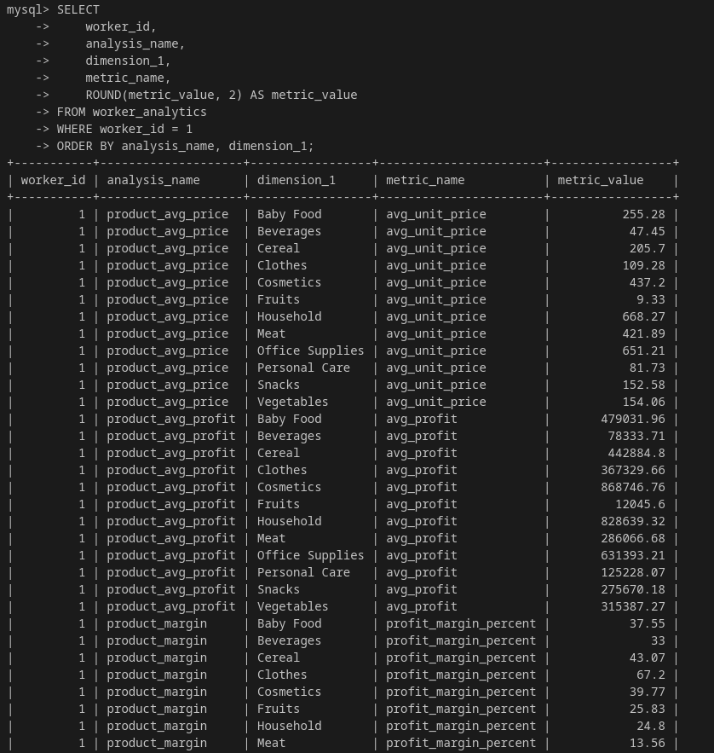

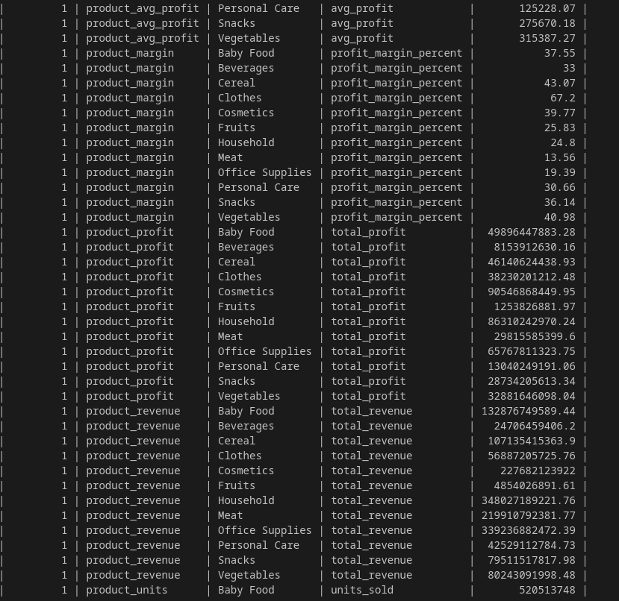

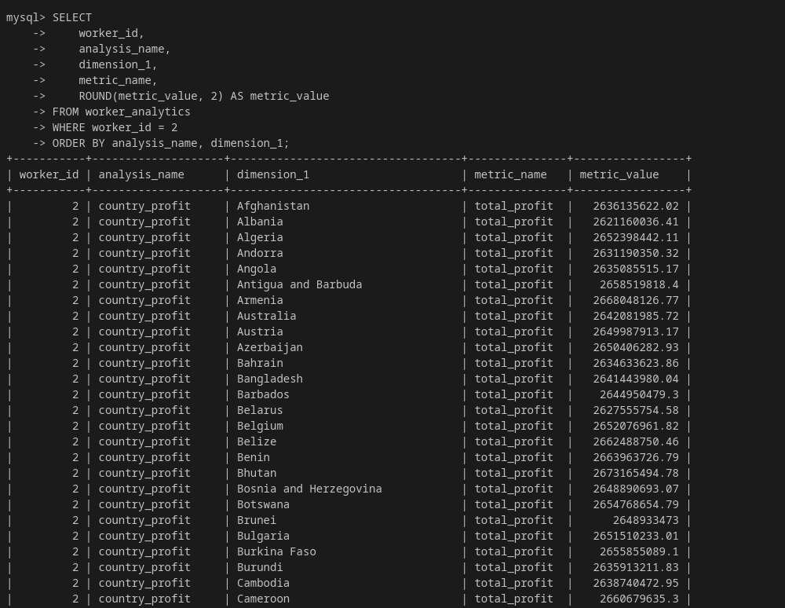

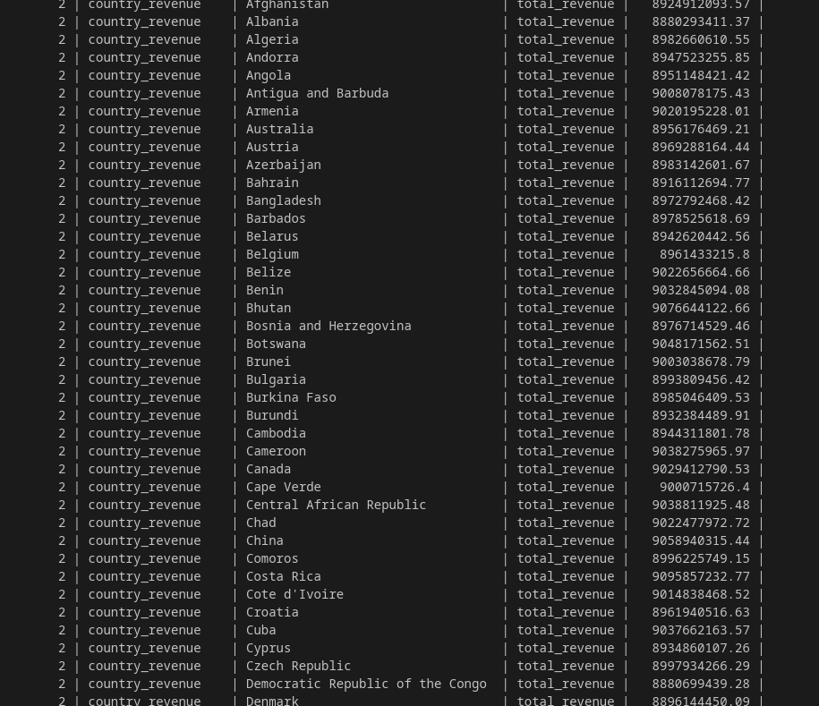

you can see combination of both result in database

